**School Site Council Meeting**

2/5/20

*The Career Academy*

*Building relationships with each other, ourselves and our community.*

*Purpose: To inform decision making for school improvement*

**2:00-2:10** Welcome and Icebreaker

**2:10-2:12** Review Norms

Be respectful of time

Stay on task

**“**Park” topics for further discussion

Assume positive intent

Be present

**2:12-2:14** Roles

Note Taker

Time Keeper

**2:14-2:20** Review 1/12/21 Meeting Notes

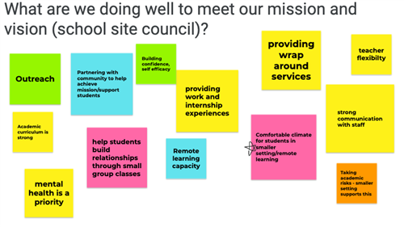

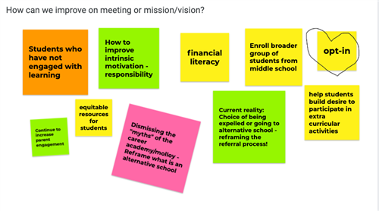

**Topics to explore**

Consider proposed edits and be prepared to vote next

Incorporate feedback

Help middle schools identify students- put out student profiles, parent info sessions

Keep an eye on middle school high-school sign up schedule

Finalize mission and vision statements

How to make this as an opt-in program for incoming freshmen?

**2:20-2:25** Vote on Proposed Mission and Vision

**Mission and Vision**

The Career Academy (continuously) engages students to take control of their learning through student-led inquiry, positive relationship building, work-based learning, and wraparound supports. They acquire academic, social emotional, and industry specific competencies that transfer to real-world scenarios in their community and professional futures.  

**Vision Statement**

Students are in the driver’s seat on their road to success. They develop skills for personal, academic, and professional success beyond high school through a curriculum rooted in student-led inquiry, social-emotional development, and career connections. They will persevere toward their goals supported by positive relationships built with their peers, teachers, and mentors. They will explore college and career pathways through hands-on exposure to industry and fields of study, discovering their passion that will launch their post-graduation life. Graduates will continue as lifelong learners, with the relationship building, critical thinking, and field-based skills to make a positive impact on the world.

**2:25-2:50** Review Staff Needs Assessment

Review Protocol

Review areas of strength

Review areas in need of growth

Determine what the school can do to address areas in need of growth

Brainstorm- mind dump

Narrow Down Top 2 in Each Area

[Assessment](https://docs.google.com/forms/d/1zZN4v2hNOmky-0HR_XrWutIbOEmZd1uVnnH1IgLpkBU/edit#responses)