Limited English Proficiency Taglines Cover Page
Insert local phone numbers below where a parent who is not proficient in English and/or is hearing impaired could call to get access to program information. This should be available at the school or district level where a parent can go to get any vital information about their child’s education experience.

ATTENTION: If you speak [insert language], language assistance services, free of charge, are available to you. Call 1-xxx-xxx-xxxx (TTY: 1-xxx-xxx-xxxx).

Spanish
ATENCIÓN: si habla español, tiene a su disposición servicios gratuitos de asistencia lingüística. Llame al 1-xxx-xxx-xxxx (TTY: 1-xxx-xxx-xxxx).
Vietnamese
CHÚ Ý: Nếu bạn nói Tiếng Việt, có các dịch vụ hỗ trợ ngôn ngữ miễn phí dành cho bạn. Gọi số 1-xxxxxx-xxxx (TTY: 1-xxx-xxx-xxxx).
Mandarin Chinese
注意：如果您使用繁體中文，您可以免費獲得語言援助服務。請致電 1-xxx-xxx-xxxx (TTY：1-xxx-xxx-xxxx）。
Portuguese
ATENÇÃO: Se fala português, encontram-se disponíveis serviços linguísticos, grátis. Ligue para 1-xxx-xxx-xxxx (TTY: 1-xxx-xxx-xxxx).
Russian
ВНИМАНИЕ: Если вы говорите на русском языке, то вам доступны бесплатные услуги перевода.Звоните 1-xxx-xxx-xxxx (телетайп: 1-xxx-xxx-xxxx).
Haitian Creole
ATANSYON: Si w pale Kreyòl Ayisyen, gen sèvis èd pou lang ki disponib gratis pou ou. Rele 1-xxx-xxx-xxxx (TTY: 1-xxx-xxx-xxxx).
[Insert language, as needed]

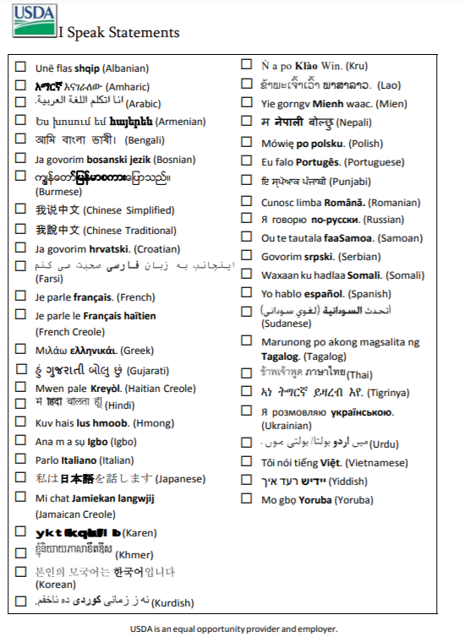
Student Name: __________________________________________
School: ________________________________________________ Grade: __________
Dear Parent/Guardian:

Lowell Public Schools is pleased to announce our participation in the Community Eligibility Provision (CEP) of the National School Lunch Program for the district of Lowell Public Schools. While all of our students have access to breakfast and lunch at no cost, this special provision means that families are no longer required to complete a meal benefit application.

School districts are still required to conduct Direct Certification and notify households of the results. This notification is to let you know that your child has qualified for free meals based on Direct Certification.

The child(ren) listed below will receive free meals at school. Students are eligible if they:
- receive MA SNAP, MA TAFDC or
- receive Medicaid AND has a family income as measured by the Medicaid Program that does not exceed NSLP income guidelines or
- live in a household with a child that receives Medicaid AND has a family income as measured by the Medicaid Program that does not exceed NSLP income guidelines
If there are other children in your household who aren’t listed, they also qualify for free meals.

If you are not receiving Supplemental Nutrition Assistance Program (SNAP) benefits and have been approved for free school meals, you may be eligible for SNAP which provides monthly financial assistance to purchase groceries to Massachusetts residents who qualify. Find out if you are eligible for SNAP today by calling Project Bread's FoodSource Hotline at 1-800-645-8333 and a counselor can help you apply over the phone. You can also apply on your own online at DTA Connect: https://dtaconnect.eohhs.mass.gov/apply

Name of Child | Name of School

Please note all schools are Community Eligible Provision and all students receive a free breakfast and lunch. Please contact me directly if you have any questions regarding this OR you do not want your children to receive free meals. If you should have any additional questions, please contact us.

Alysia Spooner-Gomez
978-674-2049
Aspooner-gomez@lowell.k12.ma.us

Sincerely,
[signature]

Non-Discrimination Statement:
In accordance with federal civil rights law and U.S. Department of Agriculture (USDA) civil rights regulations and policies, this institution is prohibited from discriminating on the basis of race, color, national origin, sex (including gender identity and sexual orientation), disability, age, or reprisal or retaliation for prior civil rights activity.
Program information may be made available in languages other than English. Persons with disabilities who require alternative means of communication to obtain program information (e.g., Braille, large print, audiotape, American Sign Language), should contact the responsible state or local agency that administers the program or USDA’s TARGET Center at (202) 720-2600 (voice and TTY) or contact USDA through the Federal Relay Service at (800) 877-8339.
To file a program discrimination complaint, a Complainant should complete a Form AD-3027, USDA Program Discrimination Complaint Form which can be obtained online at: https://www.usda.gov/sites/default/files/documents/USDA-OASCR%20P-Complaint-Form-0508-0002-508-11-28-17Fax2Mail.pdf, from any USDA office, by calling (866) 632-9992, or by writing a letter addressed to USDA. The letter must contain the complainant’s name, address, telephone number, and a written description of the alleged discriminatory action in sufficient detail to inform the Assistant Secretary for Civil Rights (ASCR) about the nature and date of an alleged civil rights violation. The completed AD-3027 form or letter must be submitted to USDA by:
- mail:
U.S. Department of Agriculture
Office of the Assistant Secretary for Civil Rights
1400 Independence Avenue, SW
Washington, D.C. 20250-9410; or
- fax:
(833) 256-1665 or (202) 690-7442; or
- email:
program.intake@usda.gov
This institution is an equal opportunity provider.
Dear Parent/Guardian:

[School District] is pleased to announce our participation in the Community Eligibility Provision (CEP) of the National School Lunch Program (NSLP) for the following schools: [Complete if the district is not District Wide CEP]. This special provision allows our school(s) to provide breakfast and lunch at no cost for all students, and families are no longer required to complete an application to access meal benefits.

School districts are still required to conduct Direct Certification and notify households of the results. This notification is to let you know that your child has qualified in the reduced price meals category based on Direct Certification. Your child will continue to receive meals at no cost.

If there are other children in your household who aren’t listed, they also qualify in the reduced price meals category. Eligible students either:
- receive Medicaid or
- live in a household with a child that receives Medicaid AND has a family income as measured by the Medicaid Program that does not exceed NSLP income standards.

If you are not receiving Supplemental Nutrition Assistance Program (SNAP) benefits and have been approved for reduced price school meals, you may be eligible for SNAP which provides monthly financial assistance to purchase groceries to Massachusetts residents who qualify. Find out if you are eligible for SNAP today by calling Project Bread's FoodSource Hotline at 1-800-645-8333 and a counselor can help you apply over the phone. You can also apply on your own online at DTA Connect: https://dtaconnect.eohhs.mass.gov/apply

Name of Child | Name of School

Please contact [school official’s name] at [phone number] or [e-mail address] if there are other children in your household who are not listed above and you would like them to be qualified for reduced price meals.

[name]
[phone number]
[e-mail address]

Sincerely,
[signature]

Non-Discrimination Statement:
In accordance with federal civil rights law and U.S. Department of Agriculture (USDA) civil rights regulations and policies, this institution is prohibited from discriminating on the basis of race, color, national origin, sex (including gender identity and sexual orientation), disability, age, or reprisal or retaliation for prior civil rights activity.
Program information may be made available in languages other than English. Persons with disabilities who require alternative means of communication to obtain program information (e.g., Braille, large print, audiotape, American Sign Language), should contact the responsible state or local agency that administers the program or USDA’s TARGET Center at (202) 720-2600 (voice and TTY) or contact USDA through the Federal Relay Service at (800) 877-8339.
To file a program discrimination complaint, a Complainant should complete a Form AD-3027, USDA Program Discrimination Complaint Form which can be obtained online at: https://www.usda.gov/sites/default/files/documents/USDA-OASCR%20P-Complaint-Form-0508-0002-508-11-28-17Fax2Mail.pdf, from any USDA office, by calling (866) 632-9992, or by writing a letter addressed to USDA. The letter must contain the complainant’s name, address, telephone number, and a written description of the alleged discriminatory action in sufficient detail to inform the Assistant Secretary for Civil Rights (ASCR) about the nature and date of an alleged civil rights violation. The completed AD-3027 form or letter must be submitted to USDA by:
- mail:
U.S. Department of Agriculture
Office of the Assistant Secretary for Civil Rights
1400 Independence Avenue, SW
Washington, D.C. 20250-9410; or
- fax:
(833) 256-1665 or (202) 690-7442; or
- email:
program.intake@usda.gov

This institution is an equal opportunity provider.

Dear Parent/Guardian:
If your children get free or reduced price school meals, they may also be able to get free or low-cost health insurance through Medicaid or the State Children's Health Insurance Program (CHIP). Children with health insurance are more likely to get regular health care and are less likely to miss school because of sickness.
Because health insurance is so important to children’s well-being, the law allows us to tell Medicaid and CHIP that your children are eligible for free or reduced price meals, unless you tell us not to. Medicaid and CHIP only use the information to identify children who may be eligible for their programs. Program officials may contact you to offer to enroll your children. Filling out the Free and Reduced Price School Meals Application does not automatically enroll your children in health insurance.
If you do not want us to share your information with Medicaid or CHIP, fill out the form below and send in.

(Sending in this form will not change whether your children get free or reduced price meals).

- No! I DO NOT want information from my Free and Reduced Price School Meals Application shared with Medicaid or the State Children's Health Insurance Program.
If you checked no, fill out the form below to ensure that your information is NOT shared for the child(ren) listed below:
Child's Name: ___________________________________________School:
Child's Name: ___________________________________________School:
Child's Name: ___________________________________________School:
Child's Name: ___________________________________________School:
Signature of Parent/Guardian: _______________________________________Date:
Printed Name:
Address:

For more information, you may call [name] at [phone] or e-mail: [e-mail address].
Return this form to: [address] by [date].

Dear Parent/Guardian:
To save you time and effort, the information you gave on your Free and Reduced Price School Meals Application may be shared with other school based programs for which your children may qualify. For the following programs, we must have your permission to share your information. Sending in this form will not change whether your children get free or reduced price meals.
- Yes! I DO want school officials to share information from my Free and Reduced Price School Meals Application with [name of program specific to your school].
- Yes! I DO want school officials to share information from my Free and Reduced Price School Meals Application with [name of program specific to your school].
- Yes! I DO want school officials to share information from my Free and Reduced Price School Meals Application with [name of program specific to your school].
If you checked yes to any or all of the boxes above, fill out the form below to ensure that your information is shared for the child(ren) listed below. Your information will be shared only with the programs you checked.
Child's Name: ___________________________________________School:
Child's Name: ___________________________________________School:
Child's Name: ___________________________________________School:
Child's Name: ___________________________________________School:
Signature of Parent/Guardian: _____________________________________________Date:
Printed Name:
Address:
For more information, you may call [name] at [phone] or e-mail at [e-mail address].
Return this form to: [address] by [date].

