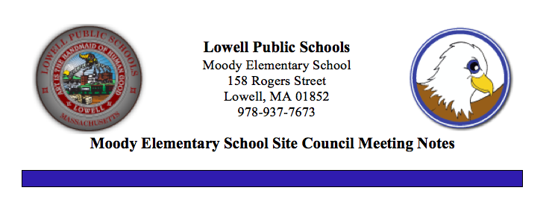

**March 11, 2020**

**Welcome and Introductions**

**SSC Updates**

* SSC is an advisory body that meets 7 times a year, consisting of school staff, administration, parents and community members.  The School Site Council works together sharing ideas and opinions to assist in the decision making at the Moody School.
* In an effort to expand our SSC membership representation, members of the PTO solicited nominations and held elections the week of February 10, 2020. We are pleased to welcome the following newly elected parent members to the SSC:

Marcela Alves

Norma Gomes

Josefina Viveiros

Sian Nu

Juliana De Souza Melo

Manpreet Dhillon

* Chair - Roberta Keefe Co-Chairs - Patricia Kennedy and Brenda Makiej

**Fair Student Funding Updates**

* Along with some other district SSCs, our SSC met at the Stoklosa School on Monday, March 9, 2020 from 6:00 PM to 7:30 PM to develop a common understanding of the SSC role, responsibilities, and expectations as well as the timelines of the school improvement and site-based budgeting processes. Guiding questions steering our work include:

1. Does our school improvement plan reflect the needs of our students?
2. Does the budget align with the school quality improvement plan? (QIP)
3. Are SSC recommendations for the budget supported by data?
4. Have staff and families been engaged in the formation of the budget?
5. Have the pros and cons of each budget decision been clearly communicated?

* Recommended Allocation for the Moody School is $2,182,327.00. Figure is based on $10,756.00 per pupil cost for 203 students. Allocation is the same as last year.

**Moody School Enrollment and Demographics**

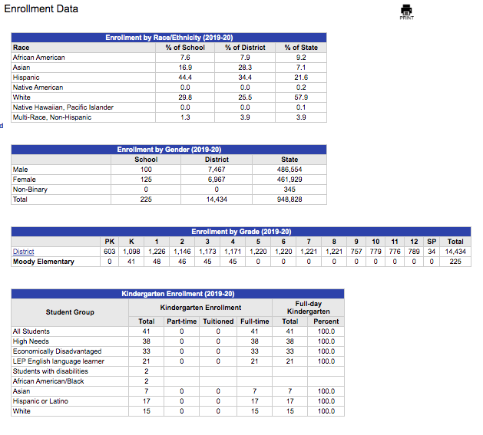

**Progress Monitoring/Curriculum Updates**

* Fountas and Pinnell testing complete
* i-Ready Math testing complete
* i-Ready Reading testing complete

**SEL Curriculum and Supports Updates**

* Additional funding donations allowed us to purchase supplemental literature to support our SEL MindUP curriculum.

**Afterschool Programing Updates**

* Kids in Tech will be getting a very special surprise on March 11, 2020
* We may get an afterschool program as well as a summer school program.

**Quality Improvement Plan Review**

|  |  |  |  |
| --- | --- | --- | --- |
| **Urgent Student Needs** | | **Strategies to Address Needs** | **Budget / Staffing Implications** |
| **Key Question: What are the urgent student needs you would like to focus on next year?** | | Key Question: What strategies and changes will you implement next year to address these needs? | **Key Questions: What are the resource implications for these strategies? Do you need to hire additional people? How much will this all cost you?** |
| The urgent needs we would like to focus on next year encompass supporting our students' educational, linguistic, and social/emotional needs. We have a transient population with a steady influx of new students. Our ever changing population has resulted in welcoming more and more newcomer students who speak little or no English. | | We will try to provide our English learners with the direct ESL instruction needed/recommended for their English proficiency levels by providing sheltered content instruction in math, ELA, social studies, and science when applicable.  Investing in 2 full-time certified ESL teachers; 1 ESL tutor; and 2 bilingual tutors to work directly with our English learners will help us move closer to compliance with the recommended ESL programs based on students' English proficiency levels and address the vast academic, linguistic, and social/emotional needs of our English learners in Kindergarten through Grade 4. | We will maintain a full time certified ELL teacher at a cost of $93,512.00. The average salary and benefits for an additional ELL Teacher is also $93,512.00. The ESL tutor cost of $15,750 is provided outside SSB. We will fund 2 bilingual tutors who will work for 15 hours a week for 33 weeks each costing $14,850.00. |
| We have a high needs population with varied levels of social/emotional needs. There is an urgent need to provide support to students, families and staff to address these needs. A major concern that needs ongoing attention is our quest to improve attendance (absences, late arrivals and early dismissal) across all grades. "Attendance Matters" and students need to be present each day to adequately access the curriculum and instructional supports to learn. | | Our 18 hour a week SEL tutor will continue to be funded to: ▪ Provide Case Management to students and families that are in need of additional support ▪ Connect with outside agencies and providers involved with families to provide coordinated support ▪ Make referrals for medical, mental health and community support as needed using a holistic approach ▪ Coordinate Mental Health service providers doing school based counseling ▪ Provide home visits to make meaningful connections with families ▪ Communicate and follow up with families at meetings, through e-mail, via telephone ▪ Monitor student attendance ▪ Provide lunch bunch support groups ▪ Provide parenting support groups ▪ Provide emergency response support to students in crisis ▪ Collaborate with school staff to coordinate individual support to students ▪ Attend IEP and TAT meetings when needed ▪ Coordinate and attend 504 meetings, complete required documentation, and disseminate information to pertinent individuals to provide accommodations | The cost for the 18 hour a week SEL Tutor for 35 weeks will be $18,900.00. |
| Our students are in need of additional assistance from paraprofessionals and tutors to support their learning across all curriculum areas. Some of our students with disabilities also need additional support from a paraprofessional in the inclusion setting to meet the goals and objectives outlined in their IEPs. |  | Paraprofessionals and tutors will be responsible and accountable for providing students with a safe, loving, stimulating and nurturing learning environment. They will work closely with the teachers and the school administrative team supporting and assisting in the implementation of the goals and objectives of the grade level or Special Education curriculum. Lesson plans and materials can be coordinated by the literacy specialist and/or teachers based on individual needs. | The average salary + benfits for a paraprofessional is $37,989.00. The total cost for 7 paraprofessionals (2 kindergarten paraprofessionals and 5 mainstream paraprofessionals) is $265,924.75. The cost for two 15 hour a week instructional tutors working for 33 weeks and one 15 hour a week Math tutor for 33 weeks, will be $14,850.00 each, totaling $44,450.00. |

|  |  |  |  |  |  |  |  |  |  |  |  |  |
| --- | --- | --- | --- | --- | --- | --- | --- | --- | --- | --- | --- | --- |
| **School** | **Enrollment** | **Grades** | **First Lang Not English** | **English Language Learner** | **Students with Disabilities** | **High Needs** | **Economically Disadvantaged** |  |  |  |  |  |
| DISTRICT | 14,434 | P-12 | 31.30% | 24% | 17.90% | 74% | 57.70% |  |  |  |  |  |
| Moody | 225 | K-4 | 54.20% | 52% | 8.40% | 88% | 72% |  |  |  |  |  |

**Source DESE 2019**

Compared to other schools in our district, our student population figures rank our school as having the highest percentage of students whose First Language is Not English (54.20%) and the highest percentage of students who are identified as English Language Learners (52%). 88% of our students are classified as High Needs and 72% are Economically Disadvantaged.

**2020-2021 Budget Review**

* Reviewed the proposed budget. There are a few discrepancies that have been corrected. The template is inaccurate; corrections are being made. This will not be a perfect process. It’s the first year in doing the budget through the SSC.  We will have to work out the kinks.
* Clarification ~ Funding is based on salary plus benefits so amounts appear inflated.
* Budget is a work in progress. No school should be losing anything.
* LPS recommended that we hire another full time ELL teacher.
* Currently there is no funding for the ELL, Math and Science Lead Teacher stipends.
* ELL Lead and Science Lead are district initiatives and should really be paid for by the district.
* We do not have a social worker funded by the district in our budget. Social emotional needs are prevalent throughout the district so it is unclear why funding is not available to us. We also have attendance issues that need monitoring and oversight. As an alternative, we have requested a full time case manager position be funded by the district for small school like ours. We have a lot of students with social emotional needs and a transient population. We are grateful for our dedicated and caring staff, especially our SEL Tutor, Mrs. Amy Doiron, as well as the support we receive from community partners to address students’ basic needs.
* SSC Members unanimously approved budget based on allocation. Members are hoping additional funding will become available to fund other needs.

**Facilities/Safety**

* Discussed adherence to fire codes and the need to be in compliance. Proposal to paint walls, cover bulletin boards with plexiglass, research fire retardant sprays etc.
* Applied for MSBA Accelerated Repair Program Grant to replace one Weil-McLain boiler.

**Professional Development Updates**

* Ms. Jan Flynn and Ms. Ellen Neither have been attending ST Math sessions and will use the train the trainer model to share information about the program with staff members.
* Wednesday, March 11th ~ Clear Touch Interactive Panel/Touch Screen Training.
* Wednesday, March 25th ~ i-Ready training during CPT.
* Literacy PD continues provided at the district level and at the school level by our Literacy Specialist, Mrs. Lisa Golner.
* Mr. Art Santos, Mrs. Kara Wilkins, and Mrs. Vero Roberts provide a variety of technology related PD to any and all staff members upon request. We are very grateful for their expertise and quick response time when assistance is requested. We are thrilled to have received a new Clear Touch Interactive Panel/Touch Screen that we will have more training on today.

**Upcoming Events/Updates**

* The Moody School was represented at district sponsored Pre-K and Kindergarten Showcases at the Shaughnessy School on Wednesday, February 26th and the McAuliffe School on Monday, March 2nd
* Kindergarten Visitation Dates for the Moody School were scheduled for Wednesday, March 4th from 9:00 AM -10:30 AM; Tuesday, March 10th from 10:30 AM – 12:00 Noon; and Tuesday, March 17th from 1:00 PM – 2:30 PM.
* Talent Show was held on Wednesday, February 26th
* Story Night was held on Thursday, February 27th
* Community Readers celebrated Read Across America on Friday, February 28th
* We decided to postpone the Cultural Breakfast due to too many illnesses.
* The Moody School will host ELPAC Meet and Greet for all ELL families on Thursday, March 19th /from 6:00 PM - 8:00 PM.
* Citywide Art show is Saturday, April 4th

**Open Forum**

**Next Meeting:  April 8, 2020**