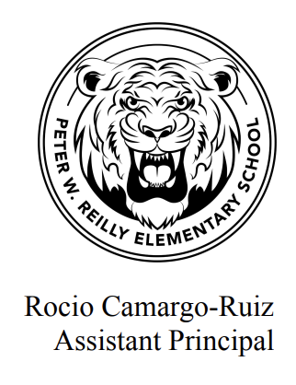

Ron Fusco

Interim Principal

September 7, 2022

Dear Reilly Families,

We are excited to be able to offer a Before School Program, free of charge, five days per week for students in grades kindergarten through four. The program begins at 7:30 A.M. All students will enter the building using the front main doors. The schedule of the morning program will be as follows:

Mondays- Fridays:

7:30 Arrival

7:30-7:45 Reading Fun Activity

7:45-8:30 Activity of the Day

8:30 Start of the School Day

Enclosed please find a registration form. Please return the form to school by September 12, 2022. We have limited spots available, so it will be a lottery based acceptance. All families will be notified regarding acceptance into the Before School Program by September 15, 2022.

**The Before School Program will begin on September 19, 2022.**

If you have any questions, please feel free to contact one of us at the email address below.

Thank you,

Joanne George and Alisha Silvestrone

Program Directors

Joanne George

[jgeorge@lowell.k12.ma.us](mailto:jgeorge@lowell.k12.ma.us)

Alisha Silvestrone

[asilvestrone@lowell.k12.ma.us](mailto:asilvestrone@lowell.k12.ma.us)