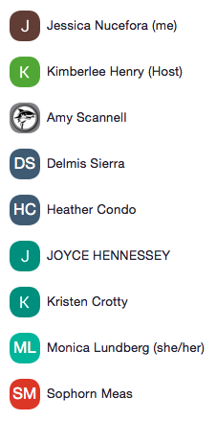

**School Site Council Meeting**

**Wednesday, February 10, 2021**

**5:30-6:30pm**

1. Welcome members and public participants

* Council Member Attendance

1. Roles and Responsibilities

* Co-Chair: Mrs. Condo
* Note Taker: Nucefora
* Time Keeper: Scannell

1. Vacant Position
   * So far only one person has self nominated
   * Maybe send out another email? Kristen Crotty will send email with deadline ASAP.
   * Ms. Lundberg: Do we need to reach out to more parents? Dr. Henry will double-check the regs about balancing. 4 teachers/4 parents
   * Ms. Scannell: For next round of elections maybe set term limits and/or participation expectations?
   * Ms. Lundberg: Let’s table until we get the QIP and Budget worked out for next year.
2. School Improvement Plan Review/Update: Session One

* Reviewed draft of QIP – Update goals from development to strengthening and building on the foundations (See Draft)
* Leadership column: Ms. Crotty: Can we add collaborative time between paras, tutors, specialists, tutors, and gen ed. Teachers? Dr. Henry: Good idea, difficult to implement based on coverage of classrooms. Maybe during workshop days? (Tutors not available) Ms. Lundberg: Perhaps phrase like “explore opportunities” to give us some leeway.
* Practices for improving instruction: Draft Approved.
* Student Specific Supports: Draft Approved.
* School Climate and Culture: Ms. Crotty: Can we add a parent component to help parents understand what the students need in school and how to help their students? Dr. Henry – will add a bullet to the column.

Next Meeting: March 10. QIP will be submitted on March 10. Unanimous Pass!

1. Public Participation