Site Council Meeting

April 1, 2019

3:30PM to 4:30PM

Present: Kevin, Teresa, Mary, Todd, Zach

Meeting Notes from February 4 review and accepted

School Updates

* Volleyball starts Thursday, April 4th
* Cambodian New Year – performance – May 30th during school hours
* Sprit Week – great participation
* Failure Intervention after April vacation (April 22 to June 4)
* Q3 report cards – April 11th, posting by April 8
* DESE visit April 3
* PBIS Update – Event before April vacation- Theme no zeroes
  + 7/8 Dodgeball
  + 5/6 Movie
* Schoolwide Assemblies around MCAS expectations
* Try to reduce anxiety with students for the rigorous MCAS test taking sessions
* May 17th Field Day if weather permits at Cawley Stadium
* 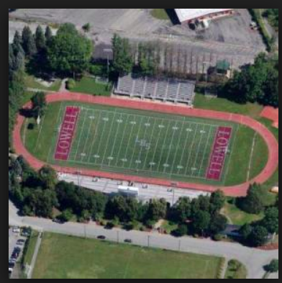

Update on Turnaround Plan

* Budget Inquiries
* Teacher Survey (93%) and Site Visit Reports
  + Reports shared at CPT in March
* Student Focus Groups
* ILT and Stakeholders Meetings: Visioning Results
* Goal to finish turnaround plan by June 4th