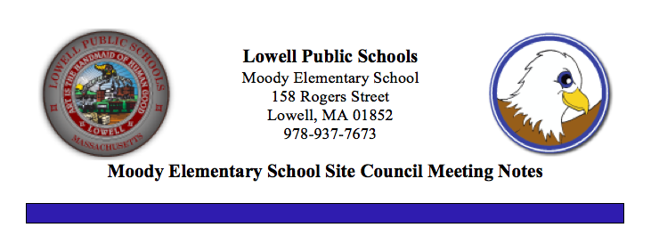

**February 12, 2020**

**Welcome and Introductions**

**What is SSC**

* SSC is an advisory body that meets 7 times a year, consisting of school staff, administration, parents and community members.  The School Site Council works together sharing ideas and opinions to assist in the decision making at the Moody School.
* *SSC Updates*
* SSC parent nominees report
* Election in Process
* Ballots due to the PTO by end of the day on Friday, February 14, 2020 for calculations
* Teachers Mr. Steve Ibarguen, Mrs. Patricia Pappathan and Ms. Priscilla Scannell nominated and elected by their peers to join the SSC

**Moody School Enrollment and Demographics**

* New students consistently arriving. Most new students are identified as ELL students. Our population is transient so overall enrollment figures remain relatively consistent with a population ranging between 230-235 students. Students move out of the district or transition to charter schools. Grade 4 teacher can only identify 25% of her students starting here in kindergarten. Additional information was sought on mid-year student emergency forms that were sent home for updated contact information asked the status of student preschool experience. This information will be added to our data inventory.

**Budget Updates**

* Final data based budget decisions need to be made by April with the support of the SSC.
* A lot of SSC activities need to be done by the end of April

**Personnel Updates**

* Congratulations to Mrs. Lindsey Gill and her husband Randy who welcomed their beautiful daughter, Carly on December 17th.
* We welcomed back Mrs. Amy Costello extend our thanks to Ms. Kristin Farley who did a fabulous job substituting.
* Mrs. Ellen Ulery joined our staff as a Long term substitute teacher for Content Literacy for the remainder of the school year.
* Bilingual tutor, Mrs. Patricia Copello, joined our staff.
* Thank you to Ms. Mary Farley for substituting daily as our Grade 2 paraprofessional. We wish Mary the best of luck as see begins her last college semester as she looks forward to graduation.

**Curriculum**

* Walkthroughs
* SEL Workshops
* ELL Strategies
* Phonics Instruction
* STEAM Activities
* Playworks
* ST Math
* Writing
* Introduction to Data Wise: A Collaborative Process to Improve Learning and Teaching
* Funds supporting Afterschool Programs

**Partnerships/After School Programs**

* Kids in Tech
* Girls Inc.
* Bill Haddad On the Move Inc.
* Book Give Away supported by Mrs. Liz Freeman and Mrs. Bonnie Callanan
* Merrimack Valley Food Bank
* Rogers Hall

**Assessment Results/Progress Monitoring**

* ACCESS Testing is complete
* Wednesday, February 12th ~ Progress Reports for Grades 1-4
* F&P testing began for Grades K-4 on Monday, February 3rd
* i-Ready Math Diagnostic Monday, February 3rd – Friday, February 14th
* i-Ready Reading Diagnostic Monday, February 24th – Tuesday, March 17th

**School Improvement Planning**

* ITL Team introduced to new document Quality Improvement Plan (QIP)
* Staff survey to make recommendations for funding distributions based on priorities
* ITL Team as well as all teachers participating in online Data Wise course Introduction to Data Wise: A Collaborative Process to Improve Learning & Teaching continue to learn about what is involved in using data wisely to build a culture of collaborative inquiry.
* Attendance, Preschool experience, Performance Data
* Curriculum (research phonics programs and costs)
* Technology needs and upgrades

**Facilities/Safety**

* Continue safety drills (fire drills, hard lockdown, soft lockdown) etc.
* Requests for fence repair and replacement of worn carpets

**Family Events**

* Family Project Valentine Cards for WWII Veterans
* MCAS Informational Breakfast Tuesday, February 11th

**Upcoming Events/ Updates**

* Vacation begins at the close of school on Friday, February 14th
* Schools Reopen on Monday, February 24th
* Preschool and Kindergarten registration will have showcases for parents to assist with registering at the Shaughnessy School on Wednesday, February 26th from 6:30 – 8:30 and the McAuliffe School on Monday, March from 6:30-8:30.
* Kindergarten Open House
* Winter Talent Show – Wednesday, February 26th
* Community Reader Day Friday, February 28th
* Cultural Breakfast Wednesday, March 18th

**Ideas/ Suggestions/Topics for Remainder of School Year**

* After School tutoring program will be considered. No transportation available

**Open Forum**

* Calendar updates

**Next Meeting:  March 11, 2020**